
FURTHER EDUCATION AND TRAINING CERTIFICATE: INFORMATION TECHNOLOGY: SYSTEMS DEVELOPMENT
ID 78965 LEVEL 4 – CREDITS 165
US ID: 119459
LEARNER GUIDE
WRITE/PRESENT/SIGN FOR A WIDE RANGE OF CONTEXTS

Learner Information:

Details | Please Complete this Section
Name & Surname:
Organisation:
Unit/Dept:
Facilitator Name:
Date Started:
Date of Completion:

Copyright
All rights reserved. The copyright of this document, its previous editions and any annexures thereto, is protected and expressly reserved. No part of this document may be reproduced, stored in a retrievable system, or transmitted, in any form or by any means, electronic, mechanical, photocopying, recording or otherwise without the prior permission.

Key to Icons
The following icons may be used in this Learner Guide to indicate specific functions:
  Books | This icon means that other books are available for further information on a particular topic/subject.
  References | This icon refers to any examples, handouts, checklists, etc…
  Important | This icon represents important information related to a specific topic or section of the guide.
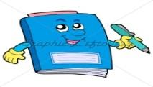  Activities | This icon helps you to be prepared for the learning to follow or assist you to demonstrate understanding of module content. Shows transference of knowledge and skill.
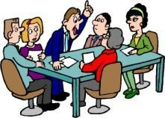  Exercises | This icon represents any exercise to be completed on a specific topic at home by you or in a group.
  Tasks/Projects | An important aspect of the assessment process is proof of competence. This can be achieved by observation or a portfolio of evidence should be submitted in this regard.
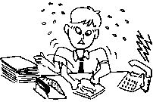  Workplace Activities | An important aspect of learning is through workplace experience. Activities with this icon can only be completed once a LEARNER is in the workplace
  Tips | This icon indicates practical tips you can adopt in the future.
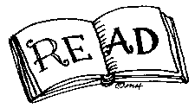  Notes | This icon represents important notes you must remember as part of the learning process.

Learner Guide Introduction
About the Learner Guide… | This Learner Guide provides a comprehensive overview of the WRITE/PRESENT/SIGN FOR A WIDE RANGE OF CONTEXTS, and forms part of a series of Learner Guides that have been developed for. The series of Learner Guides are conceptualized in modular’s format and developed for. They are designed to improve the skills and knowledge of learners, and thus enabling them to effectively and efficiently complete specific tasks.  Learners are required to attend training workshops as a group or as specified by their organization. These workshops are presented in modules, and conducted by a qualified facilitator.
Purpose | The purpose of this Learner Guide is to provide learners with the necessary knowledge related WRITE/PRESENT/SIGN FOR A WIDE RANGE OF CONTEXTS
Outcomes | At the end of this module, you will be able to:  - Accommodate audience and context needs in oral/signed communication  - Interpret and use information from texts  - Use language and communication in occupational learning programmes  - Write/present/sign texts for a range of communicative contexts  - Engage in sustained oral/signed communication and evaluate spoken/signed texts  - Write/present/sign for a wide range of contexts  - Read/view, analyse and respond to a variety of texts  - Use language and communication in occupational learning programmes
Assessment Criteria | The only way to establish whether a learner is competent and has accomplished the Learning Outcomes is through an assessment process.  Assessment involves collecting and interpreting evidence about the learner’s ability to perform a task.  This guide may include assessments in the form of activities, assignments, tasks or projects, as well as workplace practical tasks. Learners are required to perform tasks on the job to collect enough and appropriate evidence for their portfolio of evidence, proof signed by their supervisor that the tasks were performed successfully.
To qualify | To qualify and receive credits towards the learning program, a registered assessor will conduct an evaluation and assessment of the learner’s portfolio of evidence and competency
Range of Learning | This describes the situation and circumstance in which competence must be demonstrated and the parameters in which learners operate
Responsibility | The responsibility of learning rest with the learner, so:  - Be proactive and ask questions,  - Seek assistance and help from your facilitators, if required.

Learning Unit1
WRITE/PRESENT/SIGN FOR A WIDE RANGE OF CONTEXTS

Write/present/sign for a wide range of contexts

UNIT STANDARD NUMBER : 119459
LEVEL ON THE NQF : 4
CREDITS : 5
FIELD : Communication Studies and Language
SUB FIELD : Language

PURPOSE: | This unit standard will be useful to learners who communicate confidently and fluently in writing/signing in almost any formal and informal situation. Competence at this level will help learners to analyse and make mature judgements about complex, human, personal, social and environmental issues and to express and motivate own opinions.  Learners at this level write/sign expressively and with conviction on topics of interest. They cope well with the exploration of complex themes and issues in a variety of writing/signing styles that stimulate and maintain the interest of their readers/audience. Through a drafting and editing process their writing/signing shows significant improvement.  They carefully scrutinise their own and others' writing/signing in terms of its impact on different audiences and contexts. They are also able where possible to use multi-media technologies to present rather than write/sign own texts.  Learners credited with this unit standard are able to:  - Write/sign effectively and creatively on a range of topics  - Choose language structures and features to suit communicative purposes  - Edit writing/signing for fluency and unity.
LEARNING ASSUMED TO BE IN PLACE:
The credit calculation is based on the assumption that learners are already competent in terms of the following outcomes or areas of learning when starting to learn towards this unit standard: NQF level 3 unit standard. US: Write/present/sign texts for a range of communicative contexts.

SESSION 1.

WRITE/SIGN FOR A SPECIFIED AUDIENCE AND PURPOSE
Learning Outcomes
- The purpose for writing/signing, the target audience and the context are clear in relation to the learning task or activity.
- The text-type, style, and register selected are appropriate to audience, purpose and context.
- Language appropriate to socio-cultural sensitivities is selected and used in an appropriate manner without compromising own values or arguments.
- Writing/signing is well-structured and conveys its message clearly.
- Critical thinking skills are used as strategies for planning.
- Writing/signing reflects a clear point of view with sound reasons and facts to support arguments and logical development of a clearly articulated premise.
- Research skills are evident in the way data and information relevant to the context is identified, located, selected and synthesised for inclusion in the final text.

IMPORTANT
Why are you writing and who are you writing for?
Why you are writing falls into four general categories:
• to provide information
• to persuade the reader
• to give instructions
• to enact ( or prohibit ) something
Who you are writing for is determined by your identification of:
• reader type and their level of expertise - i.e. are they experts, managers, technicians
or laypersons, as well as a mixed group of readers
• reader's purpose in using the document
• reader's attitude to both you and the content of your document

1. Writing to provide information
There are various styles to use when writing to provide information.
1.1 Narrative
• Purpose is to relate or narrate a series of real or imaginary events:
EXAMPLE
It tells a story.

Simple language is usually the most effective.
• Long passages of pure narration are rare - without description or exposition it soon bores the reader.
• Present tense may be used, but be consistent! Use the same tense throughout.
1.2 Reflective
• Writer gives own opinions on a particular topic.
• Writer is seeking not to establish the truth, but to air his/her opinions.
1.3 Descriptive
• Purpose is to paint a clear and distinct picture of the person, place, issue or thing being described.
• Try to avoid over-using 'you' - instead use:
⇒ the passive voice
⇒ a fictitious observer.
1.4 Expository
♦ Purpose is to inform the reader.
♦ It is an explanation or process that emphasizes well-organised and concise information.
♦ Be careful not to show personal feelings.
♦ Report the facts as accurately as possible.
♦ Ask who?, what?, where?, when?, why? and how?
1.5 Electronic texts
♦ purpose is to represent, store or transmit information by electronic systems.
♦ transmission of information, messages, facsimiles, etc., from one computer terminal to another.
1.6 Multi-media presentations
♦ Purpose is to write presentations to be given as slide shows or presented on the computer
♦ Mainly intended as compositions in which you combine illustrations, texts, photo's, etc.
♦ Use skills in drawing, graphics and image editing, animation, photography, video and presentations, and the use of the Internet and the Web.
2. Writing to persuade the reader
2.1 Discursive
♦ Purpose is to argue about a subject.
♦ Must give BOTH sides of the argument.
♦ Sum up at the end where you may give your own point of view.
2.2 Argumentative
♦ primary purpose is to sway the reader to accept your point of view.
♦ issue must be arguable.
♦ avoid issues that cannot be won.
♦ become an expert on the issue.
♦ discuss the issue in depth so that the reader will understand the issue fully.
♦ writer must take a clear position.
♦ tone must be reasonable, professional and trustworthy.
3. Writing to give instructions
3.1 Transactional
♦ purpose is to get things done: to inform or persuade the reader to understand or do something.
♦ takes the form of letters, memos, abstracts, summaries, proposals, reports, and planning documents of all kinds.
♦ must be done clearly, correctly, concisely, coherently and carefully.
4. Writing to enact ( or prohibit ) something
4.1 Business correspondence
♦ comprises letters, faxes, e-mails, memos, but usually letters.
♦ purpose is to introduce yourself and state your objective.
♦ try to address it to a particular person by name.
♦ should be kept to one page only.
♦ should be unique and specific to the individual.
♦ remember the aesthetics - no errors, neat, good paper - proofread!
♦ opening lines:
♦ to make reference to previous correspondence
♦ to say how you found the recipient's name/address
♦ to say why you are writing to the recipient
♦ closing lines:
♦ to make a reference to a future event
♦ to repeat an apology
♦ to offer help

10 good opening lines:
♦ With reference to your letter of 8 June, I …
♦ I am writing to enquire about …
♦ After having seen your advertisement in …, I would like …
♦ After having received your address from …, I …
♦ I received your address from … and would like …
♦ We/I recently wrote to you about …
♦ Thank you for your letter of 8 June.
♦ Thank you for your letter regarding …
♦ Thank you for your letter/e-mail about …
♦ In reply to your letter of 8 June, …
10 good closing lines:
♦ If you require any further information, feel free to contact me.
♦ I look forward to your reply.
♦ I look forward to hearing from you.
♦ I look forward to seeing you.
♦ Please advise as necessary.
♦ We look forward to a successful working relationship in the future.
♦ Should you need any further information, please do not hesitate to contact me.
♦ Once again, I apologise for any inconvenience.
♦ We hope that we may continue to rely on your valued custom.
♦ I would appreciate your immediate attention to this matter.

♦ When 'Yours faithfully' and when 'Yours sincerely' in a business letter:
♦ Recipient's name is unknown to you :-
♦ Dear Sir / Madam / Sir or Madam ………… Yours faithfully
♦ Recipient's name is known to you :-
♦ Dear Mr Day / Mrs Day / Miss Day / Ms Day ………… Yours sincerely
♦ Addressing a good friend or colleague :-
♦ Dear Jack ………… Best wishes / Best regards
♦ Addressing whole departments :-
♦ Dear Sirs ………… Yours faithfully

Format of a business letter:
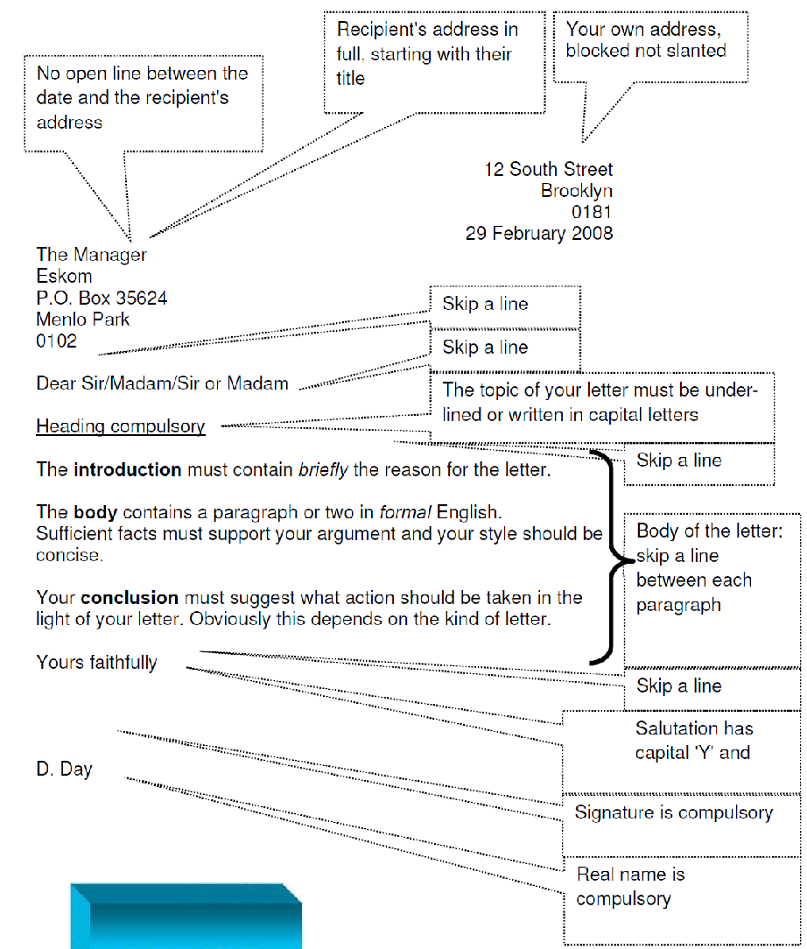

Whatever writing you do, it should always have an introduction, a body and a conclusion. This is so that the reader immediately knows what he/she is going to read about (introduction), gets all the relevant information (body) and can make sure that he/she has understood correctly and knows what to do (conclusion).
5. Reader type and their level of expertise
♦ where are the readers from?
♦ are they from within the organisation or from outside?
♦ are they from the same socio-cultural group or do they form a mixed group where various sensitivities may be present?
♦ are they experts? ( do they perhaps know more than you about what you have written? )
♦ are they managers? ( do they have more power than you? do they also know more than you about what you have written? )
♦ are they technicians? ( do they have more technical knowledge about what you have written?
♦ are they laypersons? ( are they ordinary people who know something, or nothing, about what you have written? )
♦ do the readers form a mixed group from all the above?
6. Reader's purpose in using the document
♦ do they have to read your work?
♦ do they want to read your work?
7. Reader's attitude towards you and the content of the document
♦ are they positive or negative towards you?
♦ do you hold a higher position?
♦ is there some reward in it for them?
♦ does it mean more work needs to be done?
♦ does it make them feel more positive or more negative?
8. Writer's choice of text-type, style and register
♦ How we present and tell depends on the purpose of the written task. At the beginning of this unit we looked at the purpose of a written task - please refer.
♦ How we present and tell also depends on the readers that are going to read the written task - please refer to points 5, 6 & 7.
In order for the writer to communicate the message successfully, style, text-types and register need to be well selected.
♦ Style is the manner in which a writer addresses a matter, a manner which reveals the writer's personality, or 'voice'.
♦ Text-types are used to achieve the above (style). There are ten basic text-types, namely: description; discussion; explanation; exposition; information report; narrative; poetry; procedure; recount and response.
♦ Register reflects the situation and determines the most appropriate language. Socio -cultural sensitivities must be kept in mind, so that offensive language is not used.
Own values or arguments must, however, not be compromised in doing so.
9. Writing must convey the message clearly
In order to convey a message clearly, you need to understand the communication model.
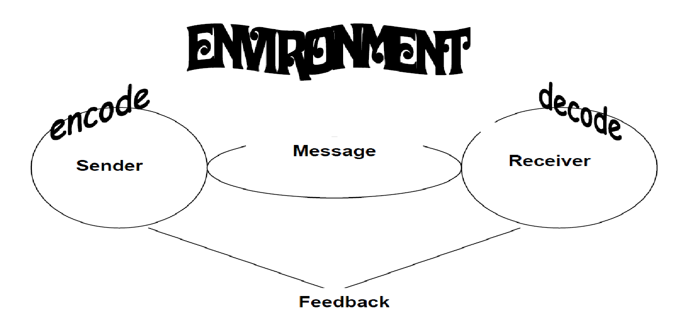
There are many factors which influence the communication process, all of which impact each other in a variety of ways.
♦ Sender - the sender is the speaker/writer. A sender starts with an impulse he or she wishes to express, and then must encode that idea into symbols (words) and signs (facial expressions, tone of voice, etc.).
♦ Message - the message is the symbols and signs which are actually transmitted. All messages are carried by a channel (face-to-face, over the phone, email, letter, etc.).
♦ Receiver - the receiver is the listener/reader. The receiver must decode the symbols and signs of the message, sent through the channel. Decoding involves working through one's own perceptual filters, to arrive at thoughts which approximate the sender's original intent.
♦ Feedback - feedback is the signs the receiver projects while the sender is sending the message. Feedback allows the sender to know how his or her message is being received, and whether the received message is the same as the intended message.
♦ Environment - environment is the physical, social and emotional influences (often referred to as 'noise'), the communication takes place in. Environments can place expectations and/or constraints on communication.
10. Critical thinking skills are to be used as strategies for planning
10.1 Brainstorming
Brainstorming is when different people who have a vested interest in the matter, get together and share thoughts and ideas on a specific topic. These thoughts and ideas should not be pre-meditated.
The following guidelines apply to ensure a successful session:
♦ write the objective - what you want to accomplish. Distribute it to the attendees, and post it for all to see during the session.
♦ invite a mix of contributors/participants. Split large groups into teams to compete.
♦ set a time limit :- 30 mins - 4 hrs
♦ announce the objective and explain the rules :-
♦ weird, wild, wacky and off-the-wall ideas are welcome -> negativity is not
♦ build on ideas -> don't shoot them down
♦ no interruptions from outside allowed (that includes cell phones!)
♦ take a short break every hour
♦ capture all ideas as they flow from the group.
♦ evaluate the ideas, selecting the best.
♦ assign next steps.
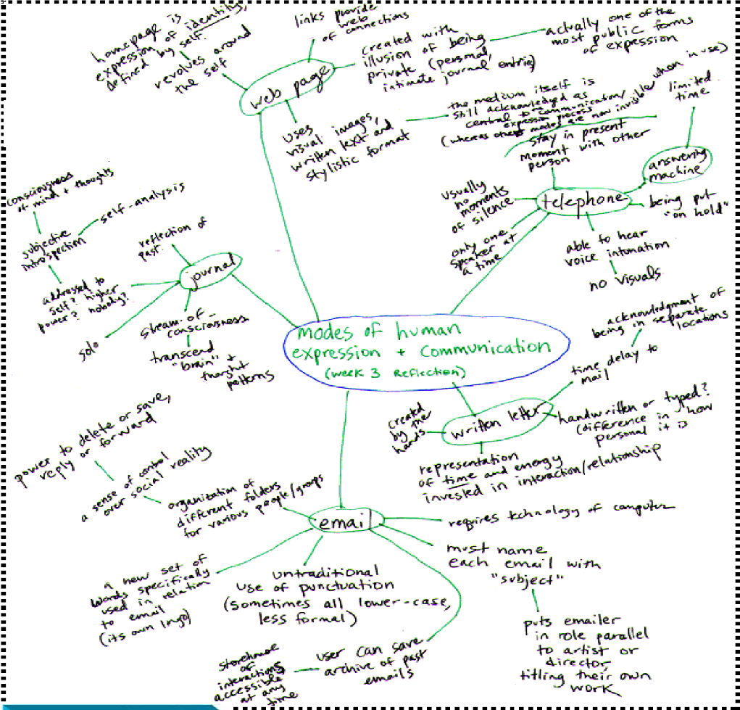
10.2 Mind-mapping
Mind maps are tools which help you think and learn. It involves writing down a central idea/topic and thinking up new and related ideas which radiate out from the centre. By focussing on key ideas written down in your own words, and then looking for branches out and connections between the ideas, you are mapping knowledge in a manner which will help you understand and remember information.
Here are some guidelines to help you do this successfully:
♦ put main idea in the centre: most people find it useful to turn their page on the side and do a map in 'landscape' style. With the main idea/topic in the middle of the page, this gives the maximum space for other ideas to radiate out of the centre.
♦ draw quickly on unlined paper without pausing, judging or editing it is important to get every possibility into the mind map. There will be plenty of time for modifying the information later on.
♦ write down key ideas
♦ look for relationships: use lines, colours, arrows, branches or some other way of showing connections between the ideas generated on your mind map
♦ Leave lots of space: after the initial drawing of the mind map, you may wish to highlight things, add information or add questions.
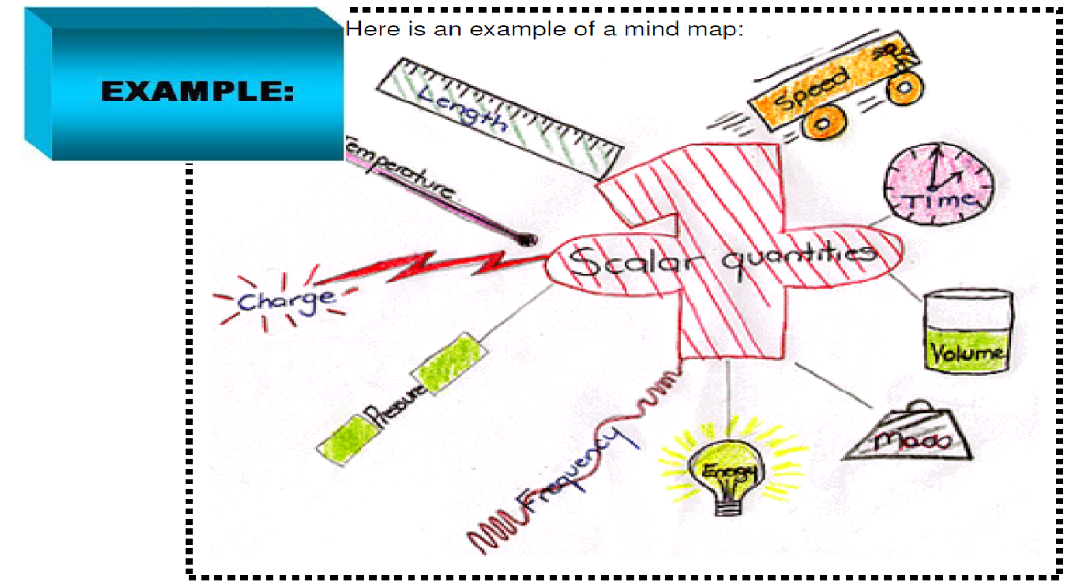
10.3. Spider diagrams
Spider diagrams are useful because they allow you to think about the main idea and then how the ideas are seen to be present elsewhere.
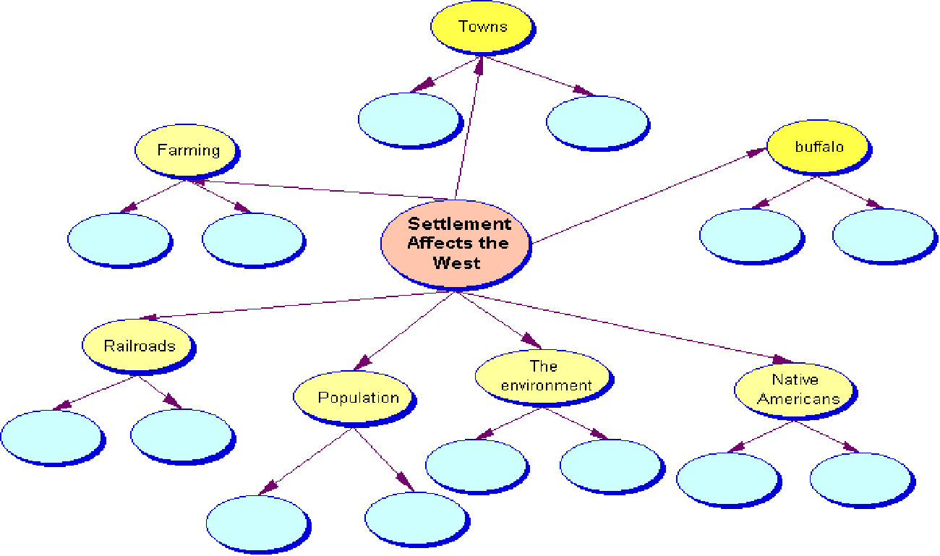
10.4 Highlighting
Highlighting words, sentences or paragraphs enables you to see what is important or relevant in a text at a glance. Take extra care when highlighting not to highlight unnecessary information. Use highlighters that are clearly visible.
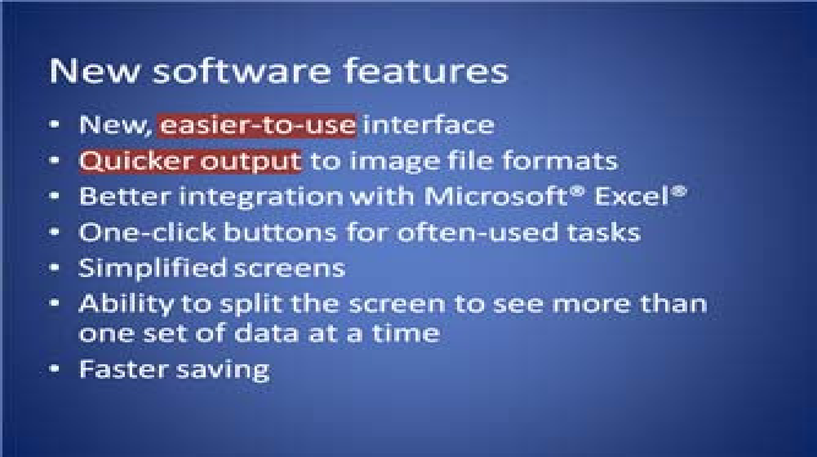
11. Research skills Focus

♦ What is my research challenge? Purpose?
♦ What are the critical questions?
♦ Define the topic statement.
♦ Who is my audience?
♦ What do I know? What do I need to know?
♦ What will my product be?

♦ How will I plan my time?
Find and Filter
♦ Locate different types of resources. (All formats)
♦ Decide which resources might be suitable.
♦ Select the most appropriate resources.
♦ Do the resources answer your critical questions?
♦ Did you find information that points you in another direction?
♦ Revise research questions if necessary.

Work with the Information
♦ Read, review, listen.
♦ Interpret, record, organize.
♦ Collect Works Cited information and quotations.
♦ Look for patterns. Make connections.
♦ Check for understanding.
♦ Review, revise, reorganize, and edit.


Communicate
♦ Prepare final results.
♦ Prepare Works Cited list.
♦ Share ideas, findings, and product.
♦ Act on findings

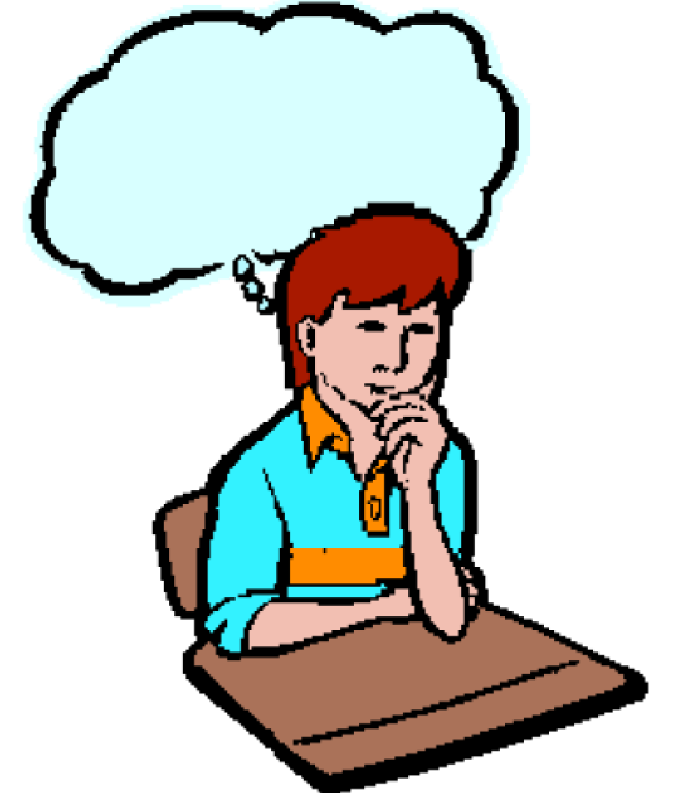
Reflect
♦ What did we learn about the topic?
♦ How does this new knowledge fit in a wider context?
♦ What worked well?
♦ What would we do differently next time?
♦ What did we learn about research?

SESSION 2.

USE LANGUAGE STRUCTURES AND FEATURES TO PRODUCE COHERENT AND COHESIVE TEXTS FOR A WIDE RANGE OF CONTEXTS.
Learning Outcomes
- Meaning is clearly expressed through the use of a range of sentence structures, lengths and types.
- The use of paragraph conventions and links between paragraphs in texts, promotes coherence and cohesion in writing/signing. Their use is explained with reference to logical progression, cause and effect and/or contrast.
- The overall structure of a piece of writing/signing is controlled and the conclusion is clearly formulated

For you to be able to produce coherent and cohesive texts, there are certain things you need to do:
♦ Make your paragraphs coherent. If necessary, rearrange sentences for better paragraph flow and logic.
♦ Use the active voice whenever the passive voice is not clearly more appropriate.
♦ Eliminate unnecessary words and phrases.
♦ Simplify your sentences. Break long sentences into manageable units.
♦ Condense repetitious or closely related material. Look for ways to combine or delete words and sentences that repeat information.
♦ Be specific. Replace vague phrases and words with more descriptive ones.
♦ Use words accurately. Look for phrases and words that don't stand up to scrutiny. In order to achieve the above, you need to understand something about the structure of the English language.
The two fundamental parts of every English sentence are the subject and the predicate. A simple sentence can also be described as a group of words expressing a complete thought. Subjects can be described as the component that performs the action described by the Predicate.
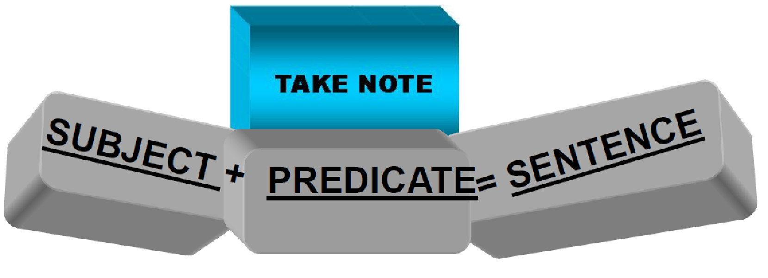
A simple sentence or independent clause must have a verb. A verb shows action or state of being. The subject tells who or what about the verb.
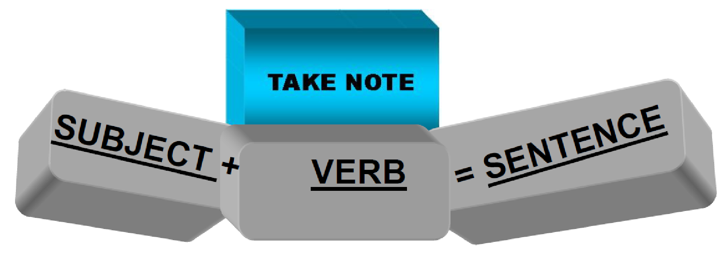

1. What makes a complete sentence?
If it helps you, think about a sentence as if it were a skeleton, the skeleton contains various bones and these bones are put together to form different parts of the body. So are sentences formed by words, the words are the bones and they are put together in different ways to form sentences.
1.1 Simple Sentences
A simple sentence contains a single subject and predicate. It describes only one thing, idea or question, and has only one verb - it contains only an independent (main) clause. Any independent clause can stand alone as a sentence. It has a subject and a verb and expresses a complete thought
• Jill reads.
Even the addition of adjectives, adverbs, and prepositional phrases to a simple sentence does not change it into a complex sentence.
The brown dog with the red collar always barks loudly. Even if you join several nouns with a conjunction, or several verbs with a conjunction, it remains a simple sentence.
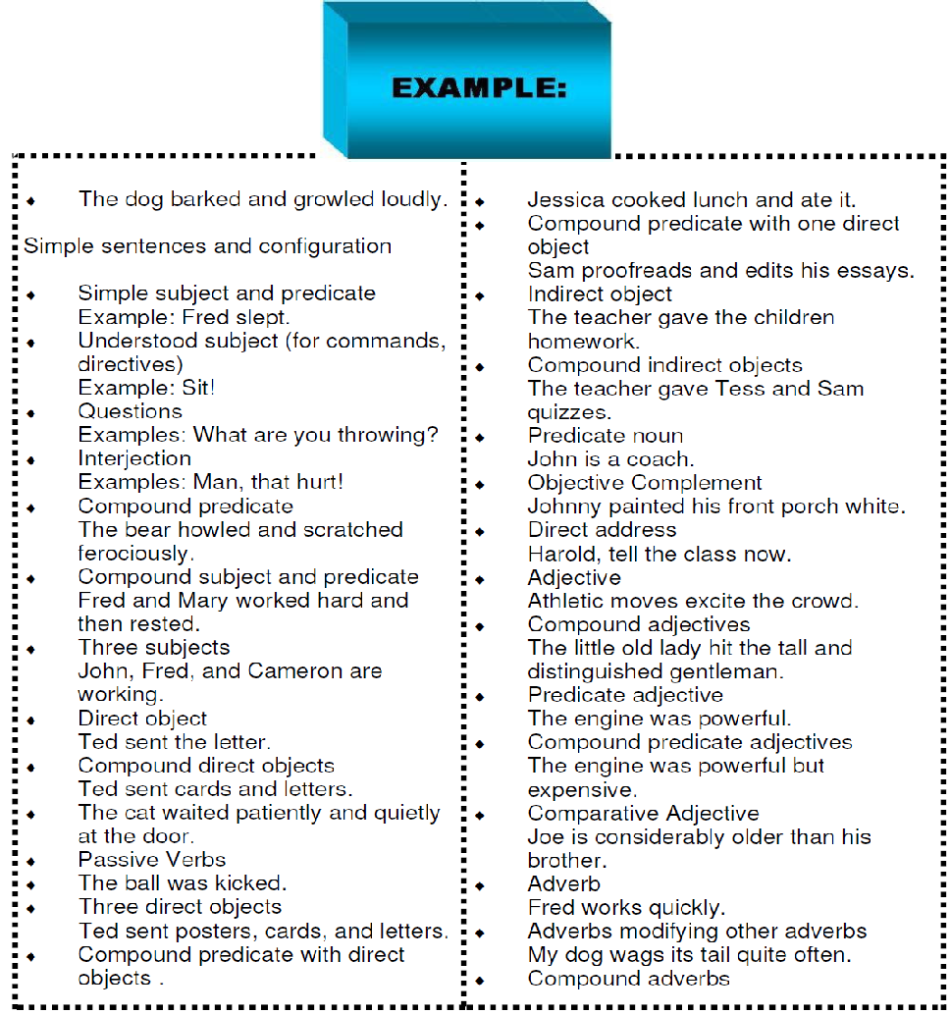
1.2 Compound Sentences

Compound sentences are made up of two or more simple sentences combined using a conjunction such as and, or or but. They are made up of more than one independent clause joined together with a coordinating conjunction.
"The sun was setting in the west and the moon was just rising."
♦ Each clause can stand alone as a sentence.
"The sun was setting in the west. The moon was just rising."

Every clause is like a sentence with a subject and a verb. A coordinating conjunction goes in the middle of the sentence, it is the word that joins the two clauses together, the most common are (and, or, but) ♦ I walked to the shops, but my husband drove.
♦ I might watch the film, or I might visit my friends.
♦ My friend enjoyed the film, but she didn't like the actor.
1.3 Complex Sentences
Complex sentences describe more than one thing or idea and have more than one verb in them. They are made up of more than one clause, an independent clause (that can stand by itself) and a dependent (subordinate) clause (which cannot stand by itself).
"My mother likes dogs that don't bark."
♦ Dependent clauses can be nominal, adverbial or adjectival.
2. The anatomy of a sentence
2.1 The Verb
The verb is the fundamental part of the sentence. The rest of the sentence, with the exception of the subject, depends very much on the verb. It is important to have a good knowledge of the forms used after each verb (verb patterns), for example: to tell
[someone] TO DO [something]
Here we can see that the verb to tell is followed immediately by a person (the indirect object, explained later), an infinitive with 'to', and, possibly, an object for the verb you substitute for DO.
Verbs also show a state of being. Such verbs, called BE VERBS or LINKING VERBS,
include words such as: am, is, are, was, were, be, been, being, became, seem, appear,
and sometimes verbs of the senses like tastes, feels, looks, hears, and smells.
"Beer and wine are my favourite drinks." The verb "are" is a linking (be) verb.
Fortunately, there are only a limited number of different verb patterns. Verbs can describe the action (something the subject actually does) or state (something that is true of the subject) of the subject
- ACTION: I play football twice a week.
- STATE: I've got a car.
Some verbs can represent both actions and states, depending on the context.
- ACTION: David's working in the bank.
- STATE: David works in a bank.
Finding the Verb
When you analyze a sentence, first identify the verb. The verb names and asserts the action or state of the sentence.
"Working at the computer all day made David's head ache."
The main verb of the sentence is "made", not working.
Verbs identify our activity or state
• eat, sleep, run, jump, study, think, digest, shout, walk ....
2.2 The Subject
The subject is the person or thing the sentence is 'about'. Often (but not always) it will be the first part of the sentence. The subject will usually be a noun phrase (a noun and the words, such as adjectives, that modify it) followed by a verb.
Finding the Subject
Once you determine the verb, ask a wh...? question of the verb. This will locate the subject(s).
♦ David works hard.
⇒ Who "works hard"?=David does=the subject.
⇒ Beer and wine are my favourite drinks.
⇒ What "are my favourite drinks"? Beer and wine
are=the subjects.

The subject(s) of a sentence will answer the questions, "who or what."
2.3 The Predicate
Once you have identified the subject, the remainder of the sentence tells us what the subject does or did. This part of the sentence is the predicate of the sentence. The predicate always includes the verb and the words which come after the verb.
♦ Michael Schumacher drove the race car.
⇒ "Michael Schumacher" is the subject; "drove the race car" is the predicate.
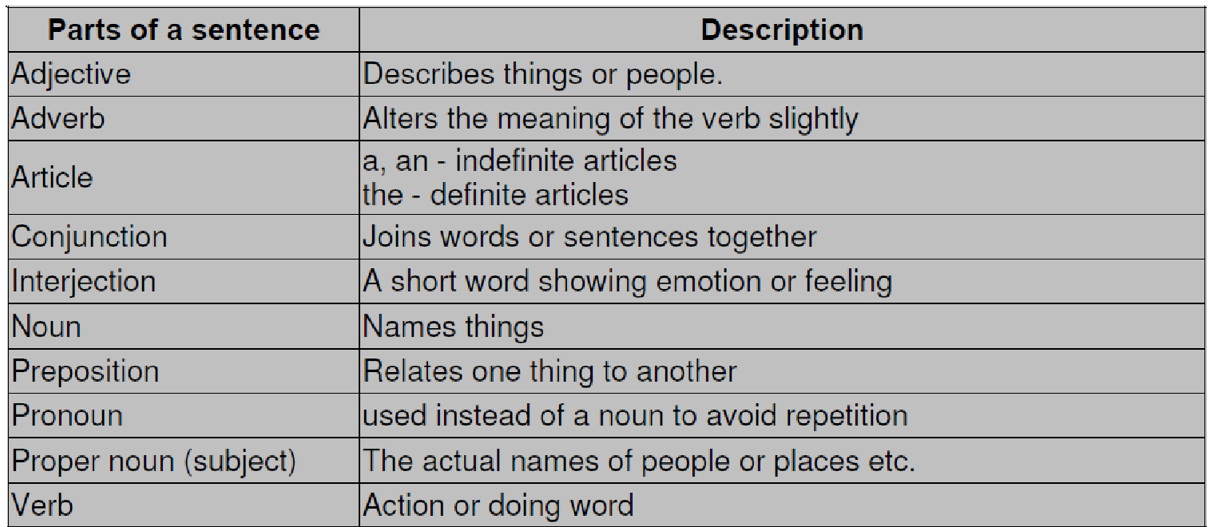

3. Four Kinds of Sentences
Let's look at four kinds of sentences: declarative, imperative, interrogative, and exclamatory.
♦ A declarative sentence makes a statement
- The hockey finals will be broadcast tomorrow
An imperative sentence gives a command or makes a request
Pass the puck to the open man.
- An interrogative sentence asks a question
Do you know the rules of hockey?
- An exclamatory sentence shows strong feeling.
Stop that man!
Declarative, imperative, or interrogative sentences can be made into exclamatory
sentences by punctuating them with an exclamation point.
4. Paragraph conventions
Organise writing with a beginning, middle and ending:
♦ organize ideas into logical chunks of information (e.g. paragraphs)
♦ use transitions to connect episodes, descriptions, explanations or facts (e.g. afterward, later on, in addition, also)
♦ describe procedures sequentially (e.g. steps in a scientific experiment)
♦ write a variety of beginnings and endings (e.g. begins with an amazing fact or background information; ends with something new to think about or a cliffhanger)
♦ organize narratives with an evident problem and solution
A paragraph is a coherent block of text, such as a group of related sentences that develop a single topic or a coherent part of a larger topic.
The beginning of a paragraph is indicated by………
♦ the beginning of the content, that is, the paragraph is the first content in the document, or
♦ exactly one blank line preceding the paragraph text
The end of a paragraph is indicated by ………….
♦ the end of the content, that is, the paragraph is the last content in the document, or
♦ one or more blank lines following the paragraph text
A paragraph should:
♦ have a topic sentence:
a topic sentence is a sentence whose main idea controls the rest of the paragraph and is usually the first sentence of the paragraph, but not necessarily, it may even be at the end of the paragraph
- Have a body
The body of a paragraph explains, develops or supports, with evidence, the topic sentence's main idea - it usually consists of supporting ideas.
- be coherent
Supporting ideas must clearly relate to the topic sentence - when sentences are connected or organised in a paragraph, a reader can easily follow a writer's train of thought. A writer can use a variety of coherence devices, such a conjunctions and pronouns, to achieve overall paragraph coherence (conjunctions - join words together; pronouns – connect ideas)
Conjunctions:
As their name implies, conjunctions join together elements of thought - words, phrases, sentences, and paragraphs. Coordinating conjunctions are the simplest kind, and they denote equality of relationship between the ideas they join. Their relatives, correlative conjunctions, not only denote equality, but they also make the joining tighter and more emphatic.
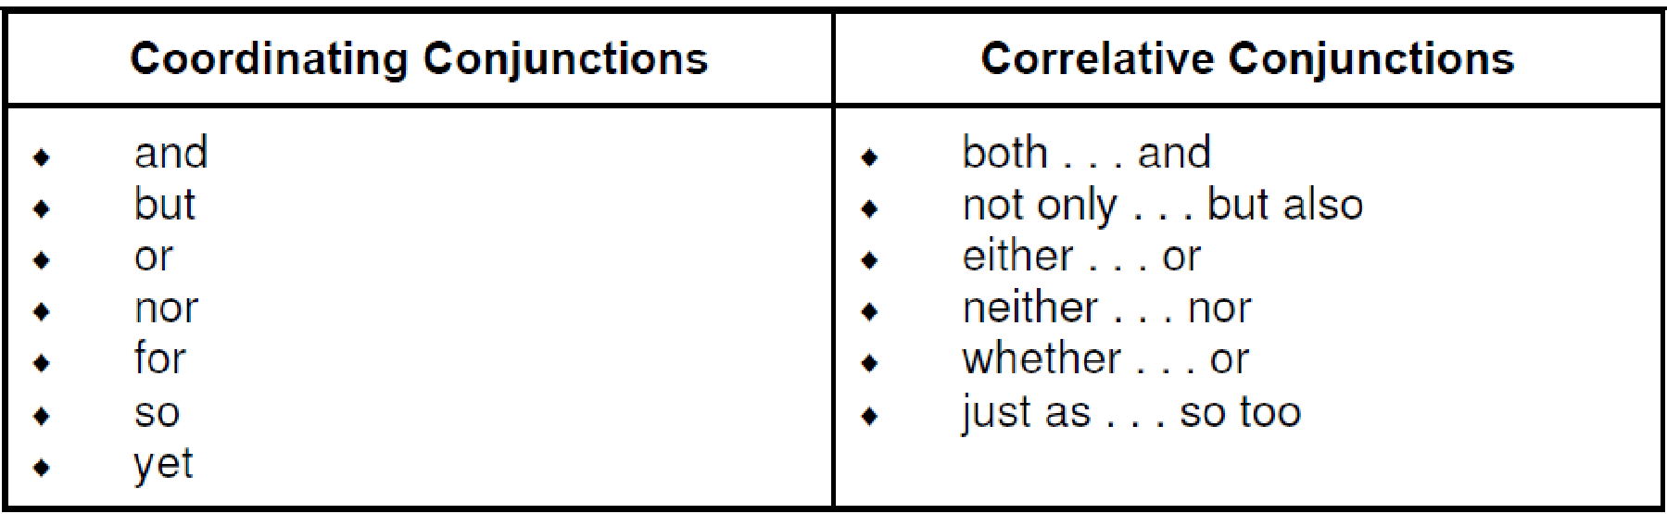
John and Sally built a fish pond.
♦ The train was late, and Tom was tired.
♦ Just as the smell of baking brought back memories, so too did the taste of the cider.
Coordinating and correlative conjunctions are great when two ideas are of the same importance, but many times one idea is more important than another. Subordinating conjunctions allow a writer to show which idea is more and which is less important. The idea in the main clause is the more important, while the idea in the subordinate clause (made subordinate by the subordinating conjunction) is less important. The subordinate clause supplies a time, reason, condition, and so on for the main clause.
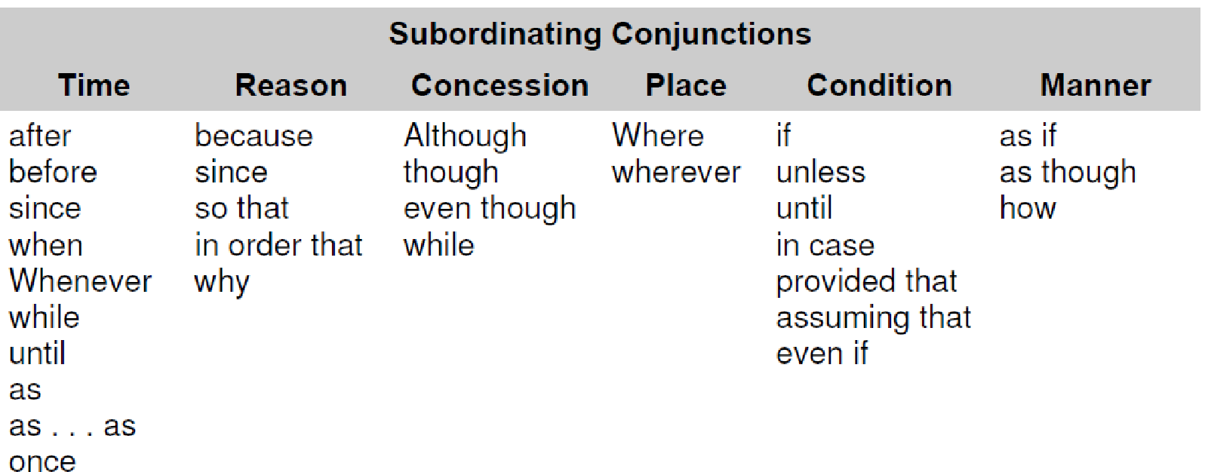
♦ Sally steamed the corn while Fred fried the steaks.
♦ After the rain stopped, the dog ran into the mud to play.
♦ The snowman melted because the sun came out.
♦ Even though John fell asleep, the telephone salesman kept talking.
Conjunctive adverbs make up an even stronger category of conjunctions. They show logical relationships between two independent sentences, between sections of paragraphs, or between entire paragraphs. Conjunctive adverbs are so emphatic that they should be used sparingly; however, when used appropriately, they can be quite effective.
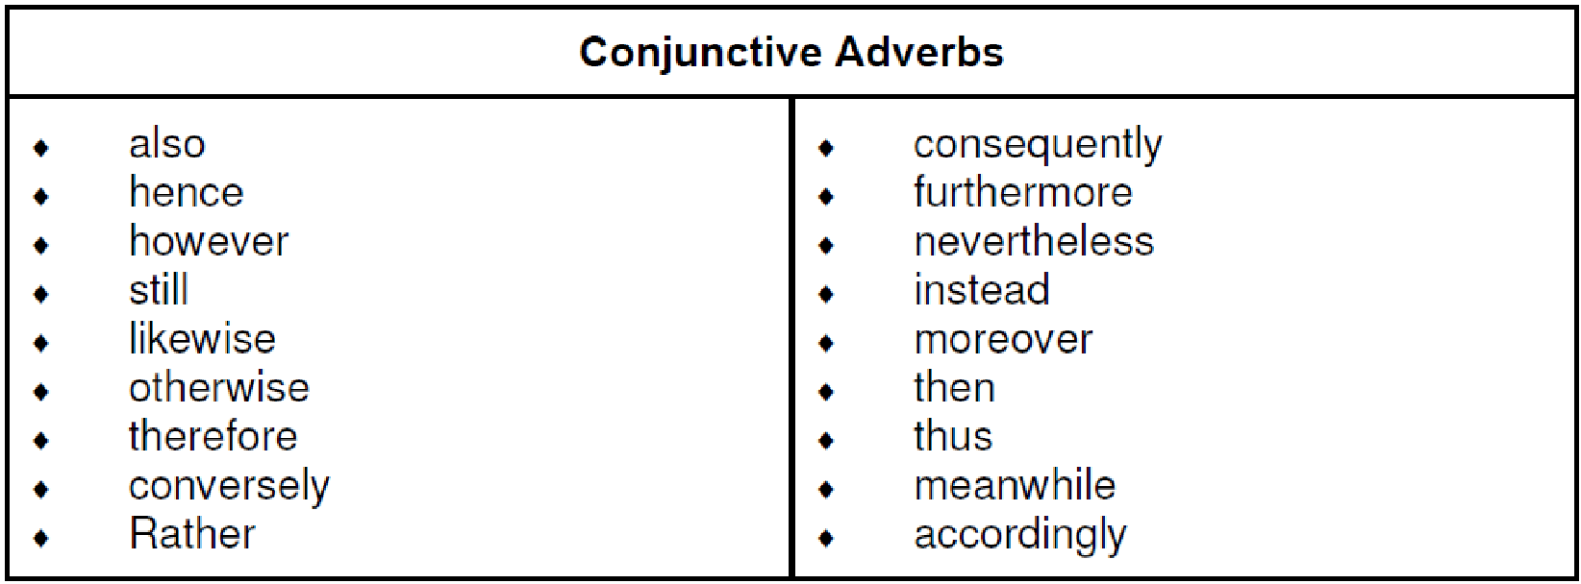

EXAMPLE
If the salmon is grilled, I will have that; otherwise, I might have the chicken.
♦ James has a garage full of wood working tools. He might, however, have some metric wrenches, too.
♦ I do not recommend that you play with a stick of dynamite lit at both ends. Rather, a ham sandwich would be better for you.

Relative pronouns and relative adjectives are also used to join ideas together by creating adjective or noun clauses, which allow a writer to create smoother, more flowing and effective sentences by combining ideas.
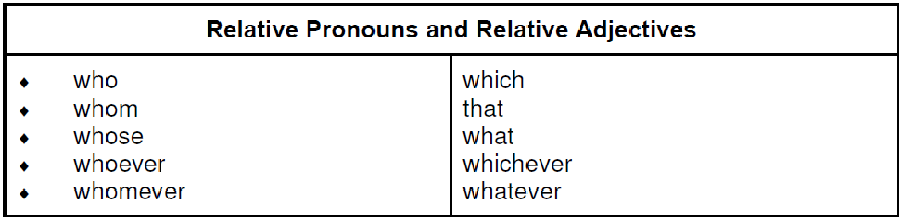
EXAMPLE
This is the man who sells peanuts.
♦ Tell me what you want.
♦ Hers is an idea that I would like to think through.
♦ The shirts, which are in the laundry, will need ironing.

Adverbs of time, place, and sequence are actually transitions of logic, but as such they also have conjunctive force, because they connect ideas by showing a time relationship.
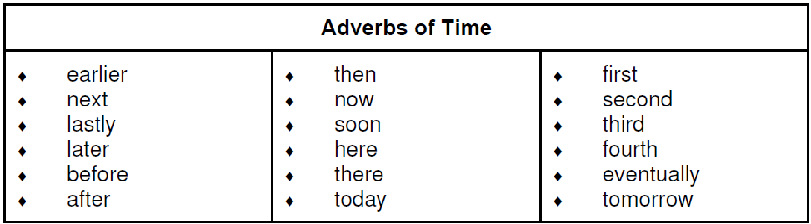
The twilight glides away. Soon night will awake.
♦ First, get a pad and pencil. Next, find a quiet place to think.

Expletives are closely related to conjunctive adverbs. The "official" line on expletives is that they convey no meaning of their own but instead serve only to emphasize the statement to which they are attached. As such, then, they technically do not show a logical relationship like time or cause between ideas, and that fact prevents them from being true-blue conjunctive adverbs. But it could be argued that expletives create a relationship of emphasis between ideas: this new idea is important in light of what preceded it. Indeed, that is why they are included here.
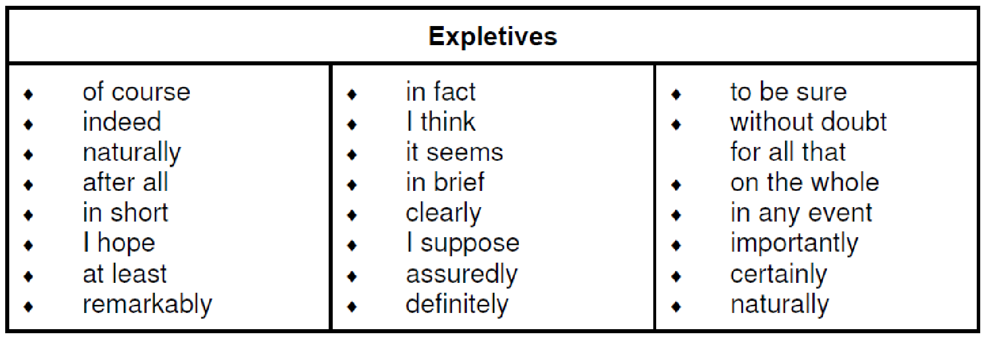

EXAMPLE
The flashlight hit the floor and broke into a hundred pieces. At least there was a candle in the room.
♦ They all began to use appropriate expletives in their writing. They were convinced, I suppose, by the excellent examples.
♦ The conjunction list has left the building. On the whole, I hope you enjoyed it.

Pronouns:
Pronouns are words that can replace or substitute a noun or a noun phrase.
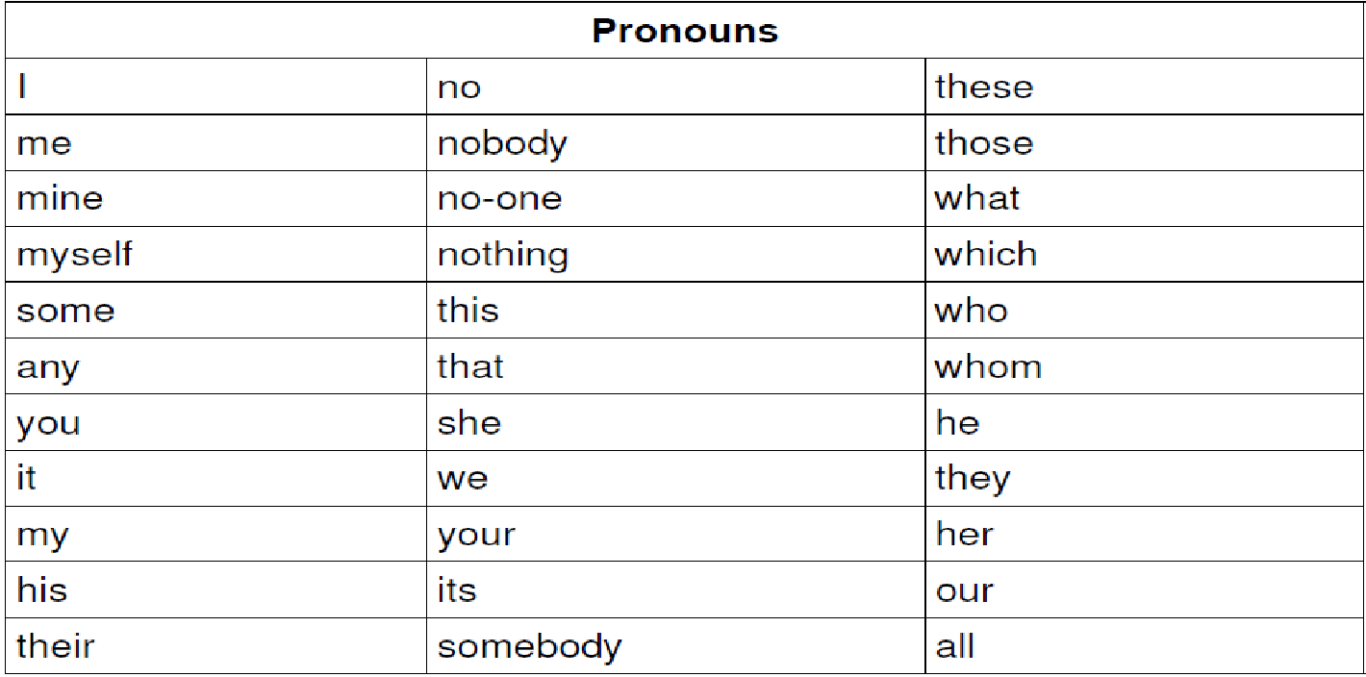
EXAMPLE
Clutching the coin, Maria ran to the shop. She went straight to the counter and bought the sweets. ("She" replaces the noun 'Maria')
♦ The 8-mile walk passes through parkland and woodland. It takes you alongside many points of
interest, including a disused airfield. ("It" replaces the noun phrase 'the 8-mile walk')

CONCLUSION!
First and last impressions are important in any part of life, especially in writing. The introduction is what makes the reader want to continue reading your paper. The conclusion is what makes your paper stick in the reader's mind. The conclusion to any paper is the final impression that can be made. It is the last opportunity to get your point across to the reader and leave the reader feeling as if he or she learned something.

SESSION 3.

DRAFT OWN WRITING/SIGNING AND EDIT TO IMPROVE CLARITY AND CORRECTNESS.
Learning Outcomes
- Writing/signing produced is appropriate to audience, purpose and context. Corrections are an improvement on the original.
- Control of grammar, diction/clarity of sign, sentence and paragraph structure is checked and adapted for consistency.
- Logical sequencing of ideas and overall unity are achieved through redrafting.
- There is clear evidence that major grammatical and linguistic errors are edited out in redrafts.
- Inappropriate or potentially offensive language is identified and adapted/removed.
- Experimentation with different layouts and options for presentation is appropriate to the nature and purpose of the task.

1. Drafting is essential!
This is because it allows you to put down your initial thoughts and then to refine them into a coherent piece of writing by redrafting until you are satisfied with the completed product.
1. Steps to follow:
♦ write down your title (heading) . Make sure you are not misinterpreting your topic
♦ decide on the tone of your written work - will it be formal, friendly, demanding, outraged?
♦ choose your tense. The past tense is easiest to use. Do not attempt mixing tenses unless you are very skilled at using the language
♦ start with a brief introduction. Write three options and decide which is the strongest
♦ divide paragraphs so as to preserve continuity. One event follows another in chronological order
♦ build sentences carefully but plainly (less is sometimes more!). Vary the lengths and don't repeat yourself
♦ vary types of sentences - statements, descriptive and more complex
♦ avoid starting sentences with conjunctions (and, but, so, then, because, well, etc.)
♦ watch spelling, punctuation and tenses
♦ use all your senses in order to obtain detail
♦ end with a conclusion that has impact. The ending is important as it's the last impression you leave your reader with. It must be strong, revealing and conclusive. It is always the final word that counts! It must give satisfaction to you as well as the reader - it must give closure.
2. Editing
Editing is when you check your essay for mistakes and correct them. No matter how sound your document may be technically, your credibility will be undermined by errors in sentence construction or grammar, word choice and usage, punctuation, mechanics or spelling. Use a ruler and don't make a sudden, hurried sweep, but look for one type of error at a time.
The editing stage goes hand in hand with drafting, as you will see that some of the steps are repeated.
Chapter headings: place chapter headings at the top of a new page. Sub-sections, unlike chapters, do not start on a new page, but are separated from the preceding section by an empty line
Quoting: this means reporting someone else's words. Remember to use quotation marks/inverted commas at the beginning and the end of the actual words that were spoken Write the way you talk: talk to your reader - simply 'talk' on paper
Use ordinary words: here are two points to think about:
♦ good professionals use ordinary words, unless they need something more precise!
♦ bad amateurs use impressive words all the time, unless they can't think of them!

